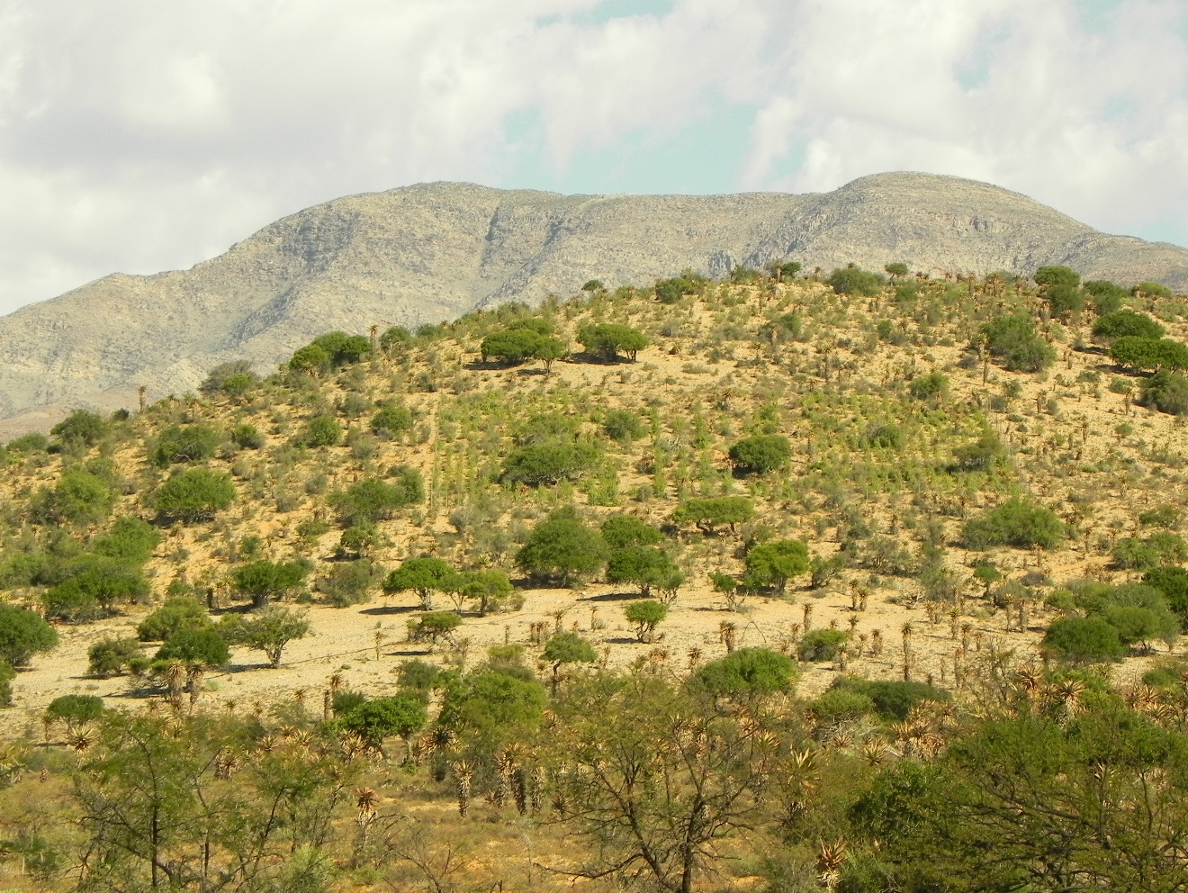

Draft 2: Standard Operating Procedure (SOP) for above ground carbon baseline monitoring

GEF5 SLM Project

Bolus C., Reeler J., Harris D., Powell M., Powell R. | Baviaanskloof | 2017/12/12

Contents

List of Figures and Tables 1

Background 1

Monitoring groups 1

Selecting monitoring sites 1

Field sampling component 3

Data tracking 3

Plot demarcation 4

Fixed point photography 6

Litter sampling 6

Woody trees, shrub and Succlent species sampling 7

Plant sample preparation 11

Plant identification 11

Warehouse and laboratory component 12

Litter analysis 12

Labeling 12

litter samples 12

Plant samples 13

Quality Control procedures 14

References 14

Annexures 16

Annex 1: Carbon Baselines Datasheets 16

# List of Figures and Tables

Figure 1 Triangulation of the corner points is done using the two corners which are 10 m apart (points a and b) for the intact sites. The third corner point (c) is then found using rope (e) to intersect it with the two 10 m ropes . For the 10 x 10 m plots the hypotenuse side (e) is 14.14 m in length while it is 28.28 m for the 20 x 20 m plots. The centre point for the plot is found by measuring halfway along the diagonal. (DEA, 2010a) 5

Figure 2: Litter collection is done using 50 x 50 cm quadrants. 7

Figure 3: Above ground woody species measured for height, canopy width and canopy length, on degraded lands on Tchnuganoo in the Baviaanskloof. 9

Table 1: List of thicket species which have allometric equations based on their canopy height, length and breadth. The list is taken from data collected from Van der Vyver’s PHD work (2017). 10

Table 2: List of thicket species which have allometric equations based on canopy area and cumulative basal stem diameter from Powell 2009. 11

# Background

The following Standard Operating Procedure (SOP) is adapted from the STRP SOP (DEA, 2010a) used for monitoring in the Addo Baviaanskloof Fish River Restoration Program (ABFRP). This was part of project document (DEA, 2010b) developed for verification of the project through VCS (Verified Carbon Standard). The ABFRP is a Department of Environmental Affairs, Natural Resource Management (DEA-NRM) restoration program. Parts of the SOP which are verbatim from the original ABFRP SOP (DEA, 2010a) are highlighted in light blue as they have not been changed, whereas the rest is an addition or adaptation to this SOP. Expert input on this SOP was given by James Reeler, Dugal Harris, Mike Powell, Rebecca Powell and Cosman Bolus. The SOP is to be used for the GEF carbon baselines assessment in the Western Baviaanskloof, South Africa.

# Monitoring groups

At each site the following groups will be monitored:

1. Litter
2. Above ground woody plant biomass

The groups are measured in order to determine the amount of carbon, and are therefore termed “carbon pools”.

# Selecting monitoring sites

1. Using the required equations from the chosen methodology (page 46 of AR-AMS0002[1]), calculate the number of required monitoring plots per stratum. Stratification criteria include:
   1. Cohort (all plantings within a 5 year period are defined as a single cohort).
   2. Burn areas (areas that have undergone a burn will be assigned to a separate “burn stratum and monitored independently).
2. Initial calculations give a number of 10 sites for each stratum, and this is expanded to 15 to ensure redundancy in case of site damage or removal.
3. Within each sub-stratum (5 year planting plan), divide the number of monitoring plots by five to obtain the number of sites to be assigned to each planting year. Randomly assign any remainder amongst the planting years.
4. Using a GIS programme, determine random locations within the area designated for each planting year. This can be done using ArcView and the “Generate Random Points” tool from the freely available Hawth’s Tools scripts[2] or some other appropriate site-selection GIS algorithm. If an alternate method is used, this must be reported and documented. Assign the number of plots per area determined in step 2.
5. Assign each monitoring plot a permanent ID, using the following structure as an example:
   1. the first letter of the protected area (A = Addo, B = Baviaanskloof, G = Great Fish River);
   2. a two-digit number for the project instance within the protected area (01 for the first, 02 for the second, etc), followed by a period (.);
   3. a three-digit number for the number of the monitoring plot within the project instance.
6. An example of a plot ID is: **A1.21**, which means Darlington Dam area, of the Addo Elephant National Park, site 21.
7. Record the ID in the project database.
8. Once monitoring has been undertaken, review the means and standard error for each carbon pool within the stratum. If the standard error is greater than 10% of the mean at a 95% confidence level, additional monitoring sites must be assigned to each stratum. The number of sites can be calculated using the equations on page 46 of the methodology.

# Field sampling component

The recommended order of procedures for a given sites is as below. It is possible to deviate from this proposed order, especially if (for example) biodiversity is to be measured across all permanent monitoring sites, followed by the remaining criteria.

1. Plot demarcation.
2. Fixed point photography.
3. Aboveground biomass assessment (All woody trees, shrub and succulent species, excluding woody forbs).
4. Litter monitoring.

Following this schedule minimizes the impacts of each procedure on the following procedure. Details of the processes are given below.

## Data tracking

A field inventory should be completed in order to ensure that no samples are lost between the field and the lab. Every time a sample is collected, register it in the field inventory. Store the field inventories with the data record sheets for the field site to allow for easy checking that all samples are present when the warehouse work is undertaken.

## Plot demarcation

For degraded sites a 20 x 20 m plot will be setup to measure above ground woody species biomass (excluding forbs). Litter quads of 50 x 50 cm in size will be setup 1m diagonally from the corners of the plot and outside the plot. A 5 x 5 m nested plot will be setup to measure all woody tree, shrub and succulent species dimensions (excluding woody forbs), whereas for the rest of the plot only woody tree, shrub and succulent species > 50 cm in height will be measured. The nested plot is setup in the SW corner of the plot.

For intact and moderately degraded sites, a 10 x 10 m plot will be setup to measure above ground woody species biomass (excluding woody forbs). Litter quads of 50 x 50 cm in size will be setup 1 x 1 m diagonally from the corners of the plot and outside the plot. A 5 x 5 m nested plot will be setup to measure all woody tree, shrub and succulent species, whereas for the rest of the plot only woody species >50 cm in height will be measured.

1. For each plot, four separate permanent markers will be placed. These comprise the four corner points of the 10 m x 10 m or 20 x 20 m plot.
2. Firstly, use the GPS coordinate specified to demarcate the southwest corner of the sampling plot. Drive an iron stake into the ground as a permanent marker, 35cm deep leaving 15cm above ground. Rocks should be placed around and on top of the stakes to ensure that animals cannot injure themselves on the stakes. If there is bedrock at the surface and the stake cannot be hit into the rock then a pile of rocks will be made up to 25 cm in height to mark the plot corner.
3. Walk 10m or 20m true north depending on whether it is a degraded, moderately degraded or intact site, and place a second marker. Each of the additional corner points can be placed by triangulation using either two tape measures or ropes of appropriate lengths. This will ensure that the plot is exactly square. The hypotenuse length should be 28.28 m for the 20 x 20 m plot and 14.14 m for the 10 x 10 m plot. .
4. Alternatively, the four corner points can be accurately placed using a highly accurate (sub-50 cm) differential GPS device.
5. Should any of the corner points be impossible to place because they coincide with the location of a tree or large bush, the entire plot should be moved up to a metre in order to accommodate the points. Try to minimise the distance by with the plot is displaced.
6. Accurately record the locations of each of the corner points in the GPS Record data sheet. Exact locations should be determined using a GPS device. Ensure that the locations are as accurate as possible.
7. The distance should be measured using a steel tape measure, and care should be taken to ensure that the line is as straight and level as possible. Use a steel pole to push the measure line through bushes and under trees that are inaccessible.
8. Once placed, all permanent markers should also be surrounded or covered with rocks, to assist in visibility and ensure that they are protected.

The biodiversity quadrants, soil plots (H1 - H6), and belt transects will not be used in the current SOP, as per the AFRP SOP.

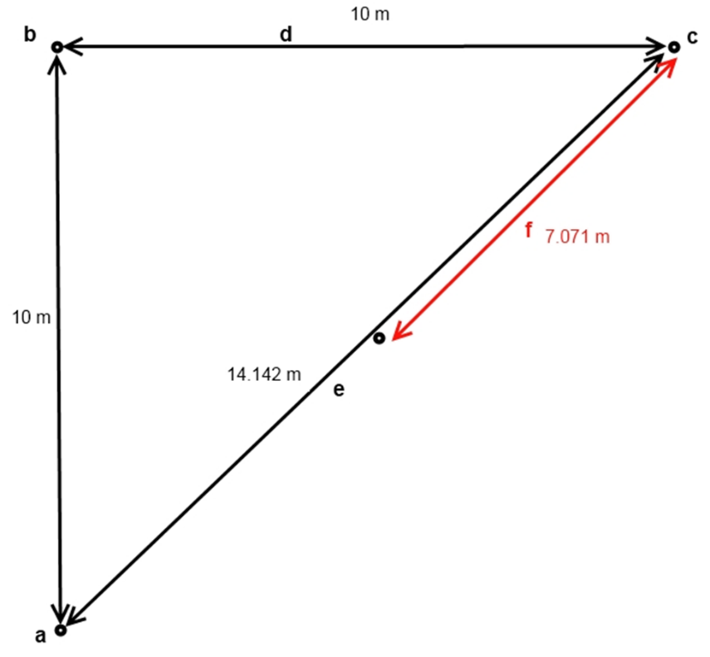

Figure Triangulation of the corner points is done using the two corners which are 10 m apart (points a and b) for the intact sites. The third corner point (c) is then found using rope (e) to intersect it with the two 10 m ropes . For the 10 x 10 m plots the hypotenuse side (e) is 14.14 m in length while it is 28.28 m for the 20 x 20 m plots. The centre point for the plot is found by measuring halfway along the diagonal. (DEA, 2010a)

## Fixed point photography

1. Fixed point photography should ideally be taken when the sun is high in the sky (i.e., not early morning or late afternoon) to ensure that the sun is not at an acute angle.
2. Set up a tripod 5m diagonally outside of the plot at each corner and aim the camera cross hair at the centre of the plot, ensuring that as much of the plot as possible is captured within the field of view of the camera. The tripod should be 1.5 m in height.
3. If there is not a good view of the plot from tripod point, move the camera up to 5 m away in order to capture a good proportion of the plot.
4. A digital copy of the fixed point photo image should be stored and backed up.
5. With a GPS, record the location of the tripod to nine decimal places in the Site Record datasheet.

## Litter sampling

This part of the sampling will not be changed except that the location of the litter quads will be 1m diagonally away from the plot at each corner.

1. Locate a point 1 m outside the plot diagonally from the edge of the corner stake.
2. Place a 50 cm x 50 cm frame on this spot.
3. Collect all the litter (leaves, fruits, small wood ≤5 cm in diameter) falling inside the frame, and place it into a plastic bag. Do not remove growing vegetation.
4. Where the frame cuts across litter, include it in the litter measurement. This avoids the difficulty of attempting to measure fractions of litter components.
5. Repeat for each of the four corners of the permanent plot, combining the litter into a single sample.
6. Label the plastic bag appropriately (see “Labeling”), and include a second label inside the bag. Seal the bag and retain it for weighing at the warehouse.

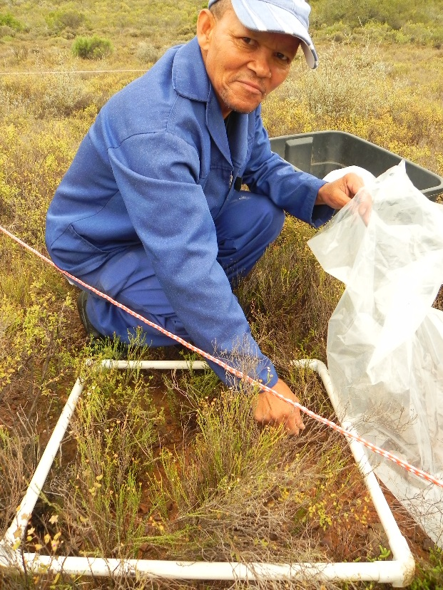

Figure : Litter collection is done using 50 x 50 cm quadrants.

## Woody trees, shrub and Succlent species sampling

1. The initial sample includes all *woody* species plants within the 10 m x 10 m or 20x 20m permanent monitoring plot. Woody species refers to woody trees and woody shrubs as well as woody succulent trees and shrubs species. Woody forbs are not included in this sampling.
2. A 5 x 5 m nested plot must be setup to measure all woody species dimensions, whereas for the rest of the plot only woody species > 50 cm in height will be measured.
3. Move from one side of the plot to the other, systematically measuring each canopy width and breadth of each plant as well as their height in the plot. Measure in cm.
4. For species with no allometric equation for canopy and height dimensions as found by Van der Vyver 2017 and Powell 2009 (see tables 1 & 2 below) namely *Aloe ferox and Euphorbia grandidens* measure the diameter of each stem with digital callipers at ground level also known as basal stem diameter (BSD). If it is not possible to measure the diameter at ground level, measure as close as possible to the ground.
5. Species which do not have an allometric equation allocated to them by either Powell 2009 or Van der Vyvyer 2017 should be measured for canopy dimensions and height so that they can be assigned an allometric equation for the plant which is closest in growth form and genus.
6. For stems with a non-circular profile, measure the widest diameter at the base of the stem.
7. Record the diameter of the stem on the datasheet and assign it a plant number (all stems from the same plant should have the same number).
8. Assign each plant with its species name or labelling code if it cannot be identified in the field
9. Once a stem has been measured, mark it with a non-damaging marker (piece of thread, spot of paint, felt-tip marker, etc.) to prevent the double-counting of stems.
10. Where the plant has a large fringe of stems growing from the ground, measure all the stems in the fringe, and then progress inwards. It is allowable to remove smaller stems in order to measure the larger stems, but try to avoid damaging the plant as much as possible.
11. Where two plants have fringes that are growing together, extend a rope between them at a point that you estimate is closest to the intersection of the two fringes. Assign all stems on the left to one plant, and all stems to the right to the other plant.

Variables to be recorded: Woody trees, shrubs and succulent canopy width, canopy length and height. For specific cases measure basal stem diameters (see table 2).

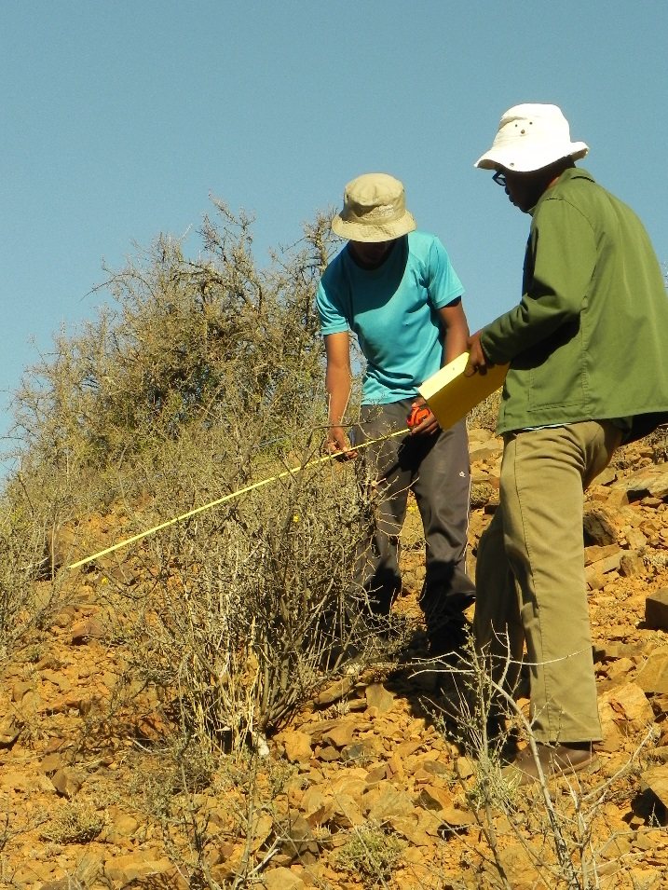

Figure : Above ground woody species measured for height, canopy width and canopy length, on degraded lands on Tchnuganoo in the Baviaanskloof.

Table : List of thicket species which have allometric equations based on their canopy height, length and breadth. The list is taken from data collected from Van der Vyver’s PHD work (2017).

|  |  |  |  |
| --- | --- | --- | --- |
| **Species name** | **n** | **x.varx** | **R2 value** |
|  |  |  |  |
| *Aloe speciosa* | 22 | CA.SL | 0.85 |
| *Aloe striata* | 15 | Hgt | 0.74 |
| *Asparagus capensis* | 16 | CD | 0.85 |
| *Azima tetracantha* | 11 | CA.H | 0.95 |
| *Blepharis capensis* | 5 | CA.H | 1 |
| *Boscia oleoides* | 14 | CA.H | 0.81 |
| *Brachylaena ilicifolia* | 13 | CD.H | 0.96 |
| *Capparis sepiaria* | 11 | CD | 0.89 |
| *Carissa haematocarpa* | 8 | Hgt | 0.93 |
| *Cotyledon velutina* | 8 | CD | 0.83 |
| *Crassula mesembryanthemoides* | 14 | CD | 0.75 |
| *Crassula muscosa* | 17 | CA.H | 0.97 |
| *Crassula ovata* | 21 | CD.H | 0.87 |
| *Crassula perforata* | 14 | CD.H | 0.98 |
| *Drosanthemum lique* | 5 | CD | 0.93 |
| *Ehretia rigida* | 8 | CD.H | 0.99 |
| *Euclea undulata* | 22 | CD | 0.95 |
| *Euphorbia coerulescens* | 15 | CA.H | 0.97 |
| *Euphorbia mauritanica* | 10 | CD.H | 0.6 |
| *Euphorbia triangularis* | 22 | Hgt | 0.98 |
| *Galenia filiformis* | 6 | CD | 0.74 |
| *Grewia robusta* | 16 | CD | 0.91 |
| *Gymnosporia polyacantha* | 15 | CA.H | 0.99 |
| *Jathropa capensis* | 4 | CA.H | 0.72 |
| *Lycium cinereum* | 8 | CD.H | 0.95 |
| *Lycium ferocissimum* | 24 | CD.H | 0.66 |
| *Malephora lutea* | 9 | CA.H | 0.93 |
| *Mesembryanthemum guerichianum* | 3 | Hgt | 0.98 |
| *Panicum maximum* | 8 | CD | 0.85 |
| *Pappea capensis* | 20 | CD | 0.98 |
| *Plumbago auriculata* | 21 | CD.H | 0.8 |
| *Portulacaria afra* | 42 | CA.H | 0.94 |
| *Psilocaulon junceum* | 8 | CD | 0.96 |
| *Ptaeroxylon obliquum* | 20 | CD.H | 0.98 |
| *Pteronia incana* | 6 | CA.H | 0.95 |
| *Putterlickia pyracantha* | 15 | CA.H | 0.78 |
| *Rhigozum obovatum* | 8 | CA.H | 0.9 |
| *Ruschia multiflora* | 6 | CA.H | 0.9 |
| *Schotia afra* | 19 | CA.H | 0.93 |
| *Vachellia karoo* | 15 | CA.H | 0.97 |

Table : List of thicket species which have allometric equations based on canopy area and cumulative basal stem diameter from Powell 2009.

|  |  |  |  |  |
| --- | --- | --- | --- | --- |
| **Species** |  | **n** | **R equation** | **R2 value** |
| *Aloe ferox* |  | *25* | Log10 *y* (C (kg) *= 1.4306*(Log10 CBSA (m2)) *+ 3.6975* | 0.7780 |
| *Euphorbia grandidens* |  | 25 | Log10 y (C (kg) = (Log10 CBSA (m2)) | 0.9249 |
| *Searsia longispina* |  | 24 | Log10 y (C (kg) = 1.1012(Log10 canopy area (m2)) - 0.2938 | 0.5077 |

## Plant sample preparation

1. Take a sample of the plant measured in the plot (a small branch with leaves, and a flower if available).
2. Label the sample (see “Labels”).
3. Stick the sample on to a piece of paper and label it with the temporary name that you have assigned it.
4. Place the sample between two pieces of paper, and place these between cardboard.
5. If you have a plant press, place the sample and cardboard into the plant press. Otherwise, store the samples under a plank on the ground, with a rock or some other weight on top to assist with the pressing process.
6. If possible, take a photo of the plant, ensuring that any distinguishing characteristics are clearly visible.

## Plant identification

1. Identify relevant plants to at least a genus level using appropriate source books.
2. If identification is not possible, send samples to an appropriate agency for identification (e.g. SANBI). If a good quality photograph has been obtained, this may be used for identification. Otherwise a mounted specimen must be sent.
3. Dry and mount plants on labelled paper in order to ensure that a permanent record of the species diversity in the site is maintained. Full details on mounting and storing specimens can be found on the SABONET website:

http://www.sabonet.org.za/reports/publications_report25.htm

# Warehouse and laboratory component

## Litter analysis

1. Record the weight of an oven tray in the Litter data sheet.
2. Place the litter from the plastic bag onto the oven tray.
3. Record the weight of the litter and tray (in grams, to 2 decimal place) in the Site Record data sheet.
4. Oven dry the sample at 60oC until it reaches a constant mass. Record the mass in grams, to one decimal place in the Site Record data sheet.
5. Constant mass is achieved when two consecutive weights taken at least four hours apart are within 0.1% of each other.

Variables to be recorded: Wet litter mass (g), dry litter mass (g).

# Labeling

## litter samples

1. For the litter samples every bag should be labelled twice, with one label attached to the outside of the bag, and a loose label on the inside of the bag. Both labels for a bag must be the same.
2. The internal labels need to be durable. Ice-lolly sticks or tongue depressors would be ideal, since they can be easily marked using a felt-tip pen, and can also be placed in the oven when samples are being dried to ensure that the samples are tracked.
3. NB: REMOVE DURABLE LABELS AND BAGS WHENEVER MEASURING MASS OR VOLUME, AS THEY WILL SKEW THE RESULTS.
4. Labels always start with the plot number. Plot number will be provided in the baseline monitoring plan provided (eg. A1.01 to A1.30)

|  |  |
| --- | --- |
| **Sample type** | **Multiple bags** |
| L = Litter | X of X |

An example of a litter label is A**1.25-L**. This means: Darlington Dam area, monitoring site 25, litter sample.

## Plant samples

1. Labels always start with the plot number at which the species was first identified. Plot numbers will be provided in the baseline monitoring plan.
2. The next part of the label is the plant form:

|  |
| --- |
| T = tree |
| Sh = shrub |
| Su = woody succulent |

1. Finally, assign the plant a unique count number, according to the number of species identified at the current site. Numbers should be assigned using a double digit assignment system (01, 02…, 99).
2. An example of a plant label is therefore: **A1.05-S-09**. This means: Darlington Dam area, monitoring site 5, shrub species, unidentified plant number 9.
3. Plant labels are temporary assignments, until the plant is identified correctly. Subsequently the plant will be labelled with the correct genus and species, and stored in the project herbarium.

# Quality Control procedures

All personnel involved in the baseline monitoring were trained adequately in the methodology so as to ensure accurate data collection. All data were entered by qualified persons. Data captured were quality controlled and checked for errors against the original sheets. Data errors were checked by a qualified ecologist. Where errors were observed, measurements on the samples were re-done and the errors corrected.

A field inventory was completed in order to ensure that no samples were lost between the field and the warehouse laboratory. Datasheets were scanned as a backup of the data. An inventory of the samples was also done at the warehouse to confirm that all samples had been stored correctly.

# References

DEA NRM, 2010a. SOP for carbon and biodiversity baselines. Unpublished internal report, Department of Environmental Affairs, Natural Resource Management Chief Directorate, 14 Loop Street, Cape Town South Africa.

DEA NRM, 2010b. Working for Water Thicket Restoration Project. Project Document. Unpublished internal report, Department of Environmental Affairs, Natural Resource Management Chief Directorate, 14 Loop Street, Cape Town South Africa.

Powell, M.J. 2009. The restoration of degraded subtropical thickets in the Baviaanskloof Nature Reserve, Eastern Cape South Africa – the role of carbon stocks and *Portulacaria afra* survivorship. MSc. Thesis. Rhodes University, Grahamstown.

Van der Vyver, M. 2017. Factors affecting effective ecological restoration of Portulacaria afra (spekboom)-rich subtropical thicket and aboveground carbon endpoint projections. PHD. Thesis. NMMU, Port Elizabeth.

# Annexures

## Annex 1: Carbon Baselines Datasheets

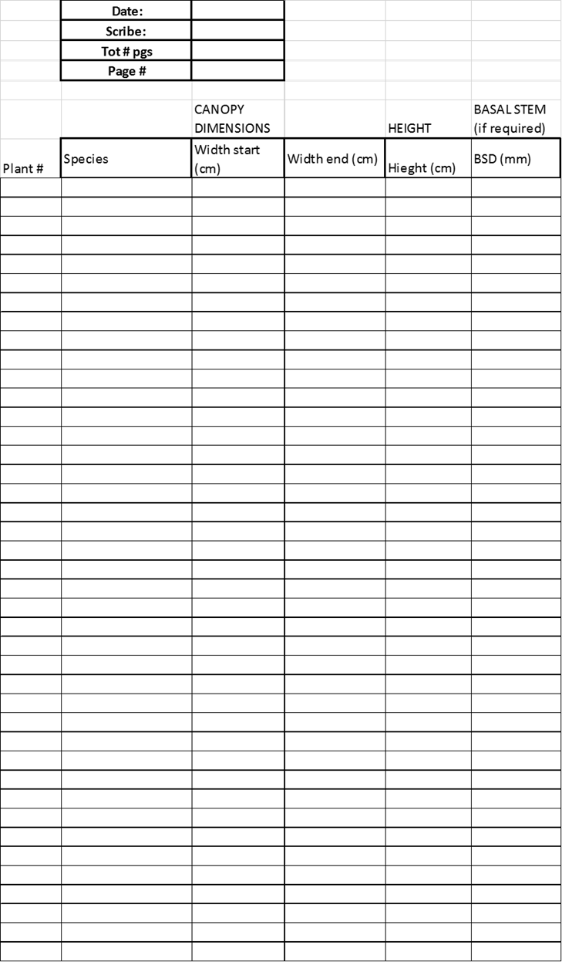







1. The methodology for this project is the CDM methodology AR-AM0002 v3: It can be downloaded from <http://cdm.unfccc.int/UserManagement/FileStorage/L1ZYHU4X5QRPFS2IVGDM8T90N3W6CJ>. However, there are a number of deviations from these equations, and consequently the Project Document should be used as a reference. The PD can be downloaded from: <http://dl.dropbox.com/u/8458610/Thicket%20project/Validation%20docs/VCS_ABFRP_PD_C4ES_05Sep2011_V3.2.pdf>
2. Available from: <http://www.spatialecology.com/htools/rndpnts.php>.